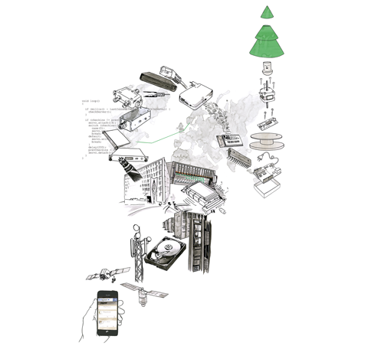

Disputas: Jørn Knutsen
Ph.d.-kandidat Jørn Knutsen forsvarer sin doktoravhandling ”Products of the Networked City” for ph.d.-graden ved AHO onsdag 10. juni. Disputasen vil foregå på engelsk.
Prøveforelesning kl. 10: Interaction Design and Tactical Media: What can be learned from historical comparative analysis?
Disputasen starter kl. 12
Om avhandlingen
This thesis addresses two interrelated issues a) how the field of interaction design is challenged by the increasing proliferation of network and computational technologies into our spatial environments, and b) how we may apply explorative interaction design practice to engage in and investigate this development through design.
These issues have been taken up through a range of research by design projects that engage hands-on with the technological infrastructures of the networked city, yet work towards a communicating and mediating output in the form of epistemic artefacts such as products, visualisation, photography and films.
Through a diverse interdisciplinary analytical framework the thesis argues that the networked city may be understood as and through heterogeneous socio-technical-cultural design materials. These materials are conditioning, shaping and abstracting design work in various ways, and are in need of a critical investigation, articulation and creative exploration through design. The thesis lays out and develops how a discursive design practice may contribute to such cultural articulations.
Om kandidaten
Jørn Knutsen (1981) is a designer, educator and researcher working with interactive products and services. He holds a master’s degree in interaction design from the Oslo School of Architecture and Design. His design and research work is centred on understanding emerging technologies through active engagement and making, such as visualisations of technology, interactive products and exhibitions. Alongside research and education at AHO he is part of the design studio Voy in Oslo doing design consultancy and developing products of their own.
Bedømmelseskomité:
- Associate Professor John Marshall, Stamps School of Arts & Design, University of Michigan. First opponent.
- Assistant Professor Anna Valgårda, IT University of Copenhagen. Second opponent.
- Associate Professor Alma Leora Culén, Department of Informatics, University of Oslo. Coordinator of the committee.
- Dato: 10.06.2015
- Tid: 10:00 - 15:00
- Sted: AHO, Auditorium Sverre Fehn
- Adresse: Maridalsveien 29, 0175 Oslo
- Kontakt: Rådgiver Reidun Høydal
- E-post: reidun.hoydal@adm.aho.no

